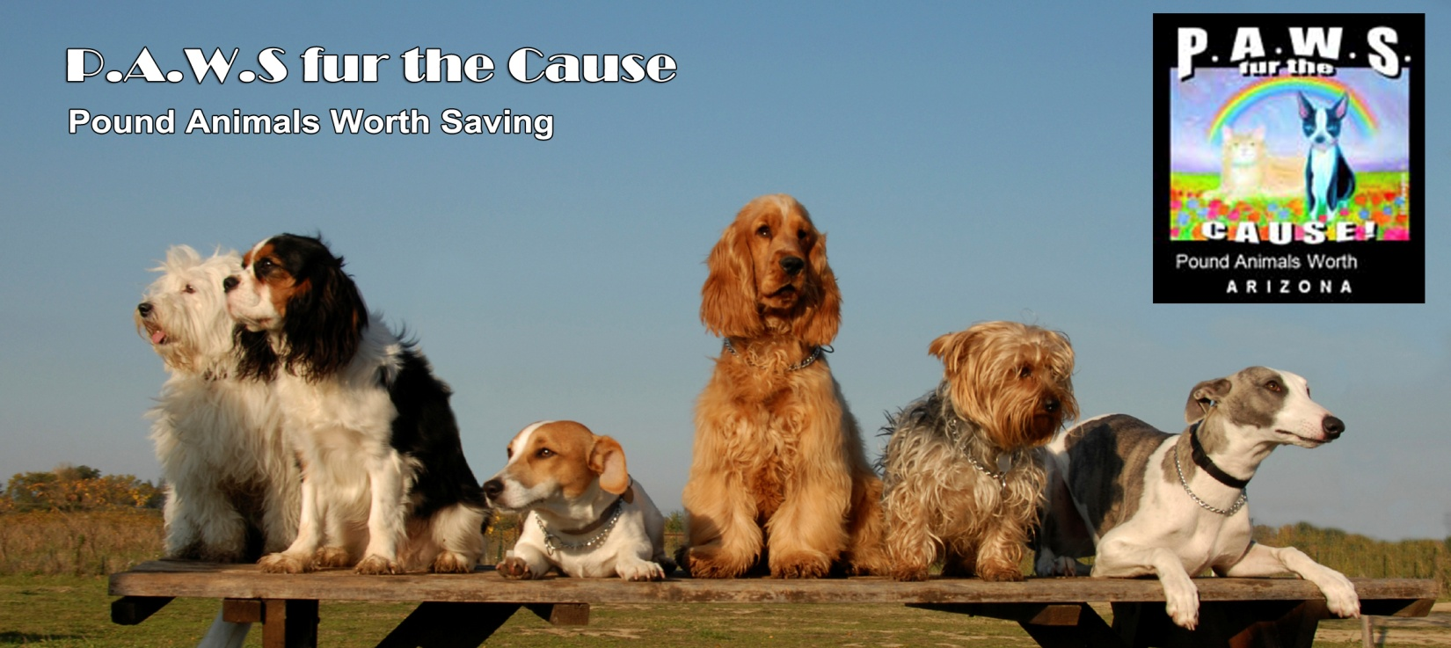
FOSTER AGREEMENT
FILL OUT THIS FORM AND RETURN TO US AS AN EMAIL ATTACHMENT, OR PRINT AND SEND VIA U.S. MAIL.
Email forms to pawsfosters1@gmail.com. Our mailing address is
P.A.W.S. Fur the Cause
Attn: Karen Mikus
2204 South Catarina
Mesa, Arizona 85202
________________________________________________________
First Name:
Last Name:
Street Address:
City/State/Zip:
Cell Phone Number:
Home Phone Number:
Email Address:
Drivers License/State and Number:
Fenced in Yard: Yes / No
Own or Rent? Own / Rent
Permission from Landlord to have pet? Yes / No
Do you have provisions for the animal 9f you have to leave? Yes / No
Number of animals in household:
Dog: Cat: Other:
Are all animals altered and vaccinated?
How many household members?
Adult: Child:
Ages of children (if any) :
Size of Animal Preferred:
How Many?

PLEASE ANSWER YES OR NO TO THE FOLLOWING QUESTIONS:
Are you willing to accept a dog that needs potty training/help/reinforcement if we provide a crate and simple instructions?
Yes / No
Do you have a doggy door?
Yes / No
What size is your doggy door?
Are you willing to help teach basic training/manners to your foster dog, such as “sit”, “stay”, “wait”?
Yes / No
Do you agree that P.A.W.S. makes all medical and adoption decisions for our dogs?
Yes / No
Do you agree to call/email your P.A.W.S. Coordinator once a week for follow-up purposes?
Yes / No
Do you agree to NEVER take your P.A.W.S. foster to a dog park and to NEVER allow your P.A.W.S. foster dog to be off leash except in your fenced yard?
Yes / No
Do you agree to NEVER take your P.A.W.S. foster dog around any ill or un- or under-vaccinated dogs, including puppies?
Yes / No
Do you agree to dop your P.A.W.S. foster dog off ar our adoption events?
Yes / No

______________________________________________________________________________
Foster Signature / Date

______________________________________________________________________________
P.A.W.S. Coordinator Signature / Date

